Task No 01: Execute all example code and attach output in your lab file.

Example # 01:
Input:
using System;

namespace Abdullah_Sadiq_CP_Lab_3
{
class Program
{
static void Main(string[] args)
{
int i = 123456;
Console.WriteLine("{0:c}", i);
Console.WriteLine("{0:e}", i);
Console.WriteLine("{0:f}", i);
Console.WriteLine("{0:p}", i);
Console.WriteLine("{0:g}", i);
Console.WriteLine("{0:x}", i);
}
}
}
Output:
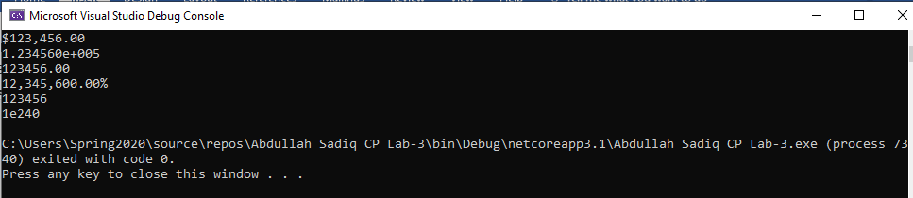
Example # 02:
Input:
using System;

namespace Abdullah_Sadiq_CP_Lab_3
{
class Program
{
static void Main(string[] args)
{
//++++Example 2
Console.WriteLine("{0:0.00}", 133.789);
Console.WriteLine("{0:0.0}", 133.789);
Console.WriteLine("{0:0.0000}", 133.789);
}
}
}
Output:
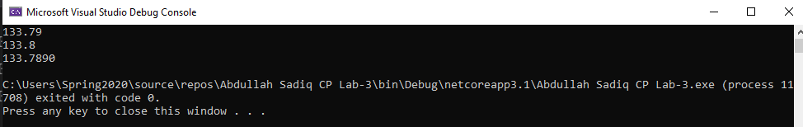
Example # 03:
Input:
using System;

namespace Abdullah_Sadiq_CP_Lab_3
{
class Program
{
static void Main(string[] args)
{
//++++Example 3
DateTime dt1 = DateTime.Now;
Console.WriteLine("{0:dd-MMM-yyyy H:mm}", dt1);
}
}
}
Output:
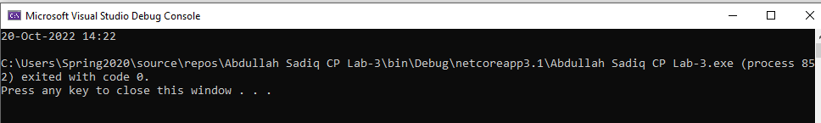
Task No 02: Create a small form which take following input from an employee of any company:
  - Name
  - Father name
  - Phone no
  - Designation
  - Date of hiring
  - Salary
Using above information display user profile in a formatted manner.

Input:
using System;

namespace Abdullah_Sadiq_CP_Lab_3
{
class Program
{
static void Main(string[] args)
{
Console.WriteLine("Enter your Name");
String name = Console.ReadLine();
Console.WriteLine("Enter your Father Name");
String fatherName = Console.ReadLine();
Console.WriteLine("Enter Your Phone No");
string phoneNo = Console.ReadLine();
Console.WriteLine("Enter Your Designation");
string designation = Console.ReadLine();
Console.WriteLine("Enter your Date of Hiring");
String dateOfHiring = Console.ReadLine();
Console.WriteLine("Enter your salary");
String salary = Console.ReadLine();
Console.WriteLine("|\tName: {0}\t\t\t|\n|\tFather Name: {1}\t\t|\n|\tPhone No: {2}\t\t|\n|\tDesignation: {3}\t|\n|\tDate of Hiring: {4}\t|\n|\tSalary: {5}\t\t\t|", name, fatherName, phoneNo, designation, dateOfHiring, salary);

}
}
}
Output:
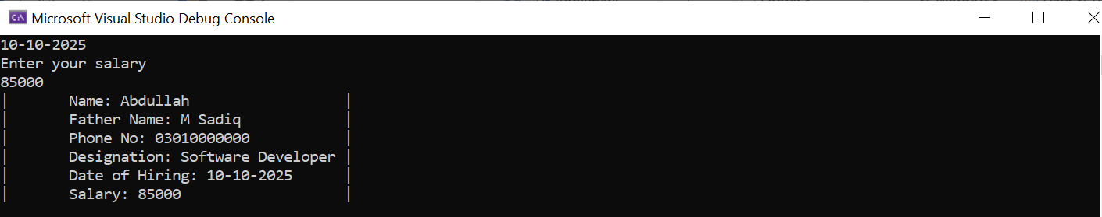

Task No 03: Create a simple C# program in which you will display the restaurant payment bill in formatted manner.

Input:
using System;

namespace Abdullah_sadiq_Lab_03
{
class Program
{
static void Main(string[] args)
{
Console.WriteLine("\tTaste a Bite\n\tHaroon Bahria Society Karachi\n\n");
DateTime dt1 = DateTime.Now;
Console.WriteLine("{0:\t\tMM/dd/yy h:mm:ss tt}", dt1);
Console.WriteLine("-------------------------------------");
Console.WriteLine("Table: 201 Chk: #1111 Guest: 2");
Console.WriteLine("-------------------------------------\n\n");
Console.WriteLine("\t 1 Zinger Burger{0,-2:C}", 5.3);
Console.WriteLine("\t 2 Paratha Rolls{0,-2:C}\n\n", 8.3);
Console.WriteLine("\t Subtotal{0,-2:C}", 13.6);
Console.WriteLine("\t Tax{0,-2:C}", 3.3);
Console.WriteLine("\t Gratuity{0,-2:C}", 2.3);
Console.WriteLine("\t Total Due{0,-2:C}\n\n\n", 19.3);
Console.WriteLine("\t Thank you For Dining With Us!\n\t\tPlease Come Again");

}
}
}
Output:
